Defense Manufacturing Community Support Program Success Story:
New Composites Master’s Program

The DoD Office of Local Defense Community Collaboration (OLDCC) Defense Manufacturing Community Support Program (DMCSP) 2020 grant to Utah, known as the Utah Defense Manufacturing Community (UDMC), provided support for a new Master’s Program in Composites at Utah State University, with Weber State University. Aerospace & Defense companies, including Northrop Grumman, L3Harris, ACT Aerospace, Hexcel, Kihomac, Albany, and Boeing, identified a need for an advanced degree program in composites to support emerging DoD programs, including Sentinel.
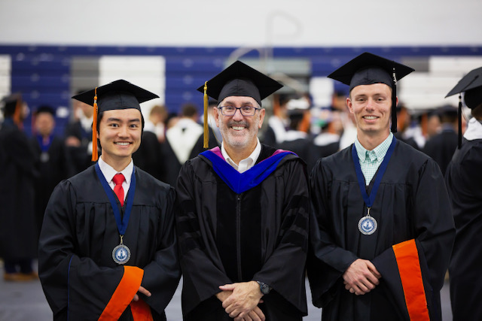
Thanks to multi-year efforts under the UDMC, the Master’s program received state funding in 2021. Utah State University developed the curriculum and hired Greg Anderson as an associate professor. The new program in Mechanical Engineering was launched in the fall semester 2022 and is the first graduate degree program in composites in the Intermountain West region and one of only a few nationwide.
Insturctor Greg Anserson with Graduates Ryan Ward and Chaz Tanoue

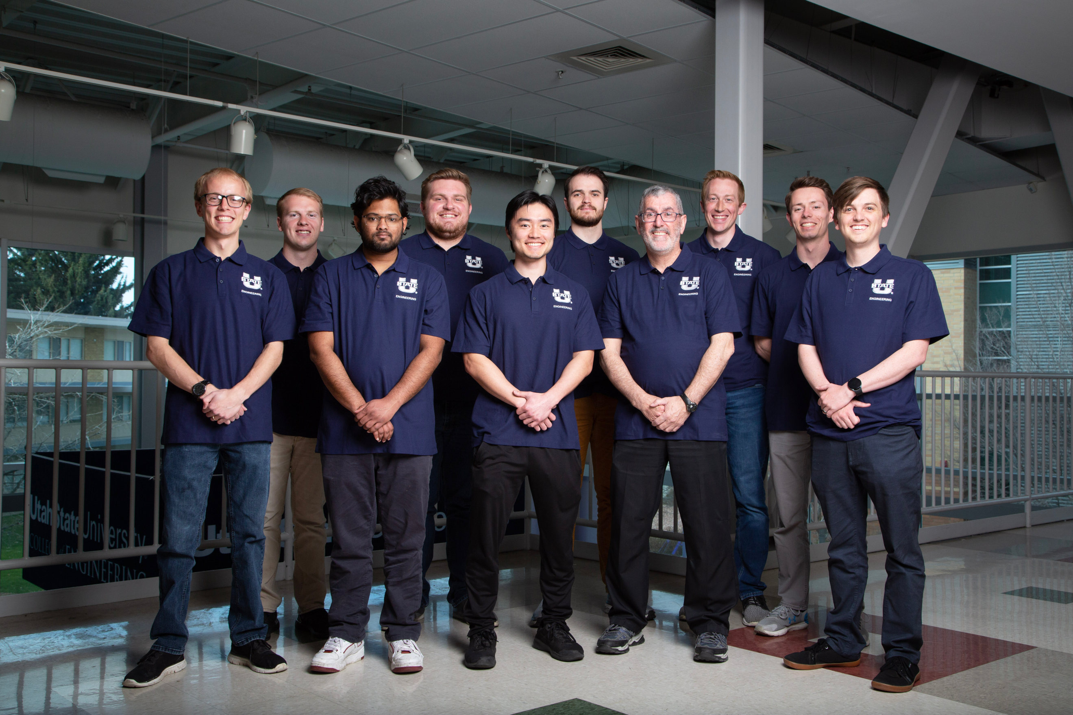
Greg Anderson, the program’s first instructor, retired from Northrop Grumman, where he had a long career in composites development and manufacturing and other advanced materials.

The new Master of Science (MS) in Composite Materials and Structures is part of the College of Engineering and was created to meet the growing need in the Aerospace & Defense industry for well-trained professionals who specialize in composite materials and structures. Course delivery can be customized to meet students’ needs with face-to-face and online options available. The program is designed for working professionals who want to expand career opportunities in the field of composite materials.

There were four students in the first cohort. While the program is designed for two years, two of the students accelerated the program and graduated in one year. The Master’s program now has eight students enrolled and will be adding a night class option.

